Week 13
- Create a function to find the sum of salaries of all employees working in depart number 10.

23.Create a trigger before/after update on the employee table for each row/statement.

22)Create a function to find the sum of salaries of all employees working in depart number 10

First of all, create employee table with attributes empid ,empname ,salary & deptno and insert values in it. Later ,execute the following code.

SQL>edit salary.sql

SUB PROGRAM:

create or replace function sumsalary(n number) return number as

cursor cur4 is select salary,deptno from employee;

c employee.salary%type;

d employee.deptno%type;

s number:=0;

begin

open cur4;

loop

fetch cur4 into c,d;

if (d=n) then

s:=s+c;

end if;

exit when cur4%notfound;

end loop;

close cur4;

return s;

end;

MAIN PROGRAM:

SQL>declare

n number;

s number;

begin

n:=&n;

s:=sumsalary(n);

if a=b then

dbms_output.put_line('sum of salaries of employees belongs to deptno'||n ||'is:'||s);

end;

/

*********************************************************************************************************

Triggers:-

Triggers: -

1)Triggers are stored programs, which are automatically executed or fired when some events occur.

2)Procedures that are implicitly executed when an insert, update or delete is issued against a table from SQL Plus or through an application are called triggers.

3)They are fired implicitly and are not explicitly called by the user.

4)Triggers are, in fact, written to be executed in response to any of the following events −
- A database manipulation (DML) statement (DELETE, INSERT, or UPDATE)
- A database definition (DDL) statement (CREATE, ALTER, or DROP).
- A database operation (SERVERERROR, LOGON, LOGOFF, STARTUP, or SHUTDOWN).

Triggers can be defined on the table, view, schema, or database with which the event is associated.

Advantages:-

1)Triggers check for the integrity of the data.

2)Forcing security approvals on the table.

3) Triggers are useful for inspecting the data changes in the tables

4)Triggers can handle errors.

5) Triggers are Used to prevent invalid transactions

Syntax:-

The syntax for creating a trigger is −

CREATE [OR REPLACE ] TRIGGER trigger_name

{BEFORE | AFTER | INSTEAD OF }

{INSERT [OR] | UPDATE [OR] | DELETE}

[OF col_name]

ON table_name

[REFERENCING OLD AS o NEW AS n]

[FOR EACH ROW]

WHEN (condition)

DECLARE

Declaration-statements

BEGIN

Executable-statements

EXCEPTION

Exception-handling-statements

END;

Where,
- CREATE [OR REPLACE] TRIGGER trigger_name − Creates or replaces an existing trigger with the trigger_name.
- {BEFORE | AFTER | INSTEAD OF} − This specifies when the trigger will be executed. The INSTEAD OF clause is used for creating trigger on a view.
- {INSERT [OR] | UPDATE [OR] | DELETE} − This specifies the DML operation.
- [OF col_name] − This specifies the column name that will be updated.
- [ON table_name] − This specifies the name of the table associated with the trigger.
- [REFERENCING OLD AS o NEW AS n] − This allows you to refer new and old values for various DML statements, such as INSERT, UPDATE, and DELETE.
- [FOR EACH ROW] − This specifies a row-level trigger, i.e., the trigger will be executed for each row being affected. Otherwise the trigger will execute just once when the SQL statement is executed, which is called a table level trigger.
- WHEN (condition) − This provides a condition for rows for which the trigger would fire. This clause is valid only for row-level triggers.

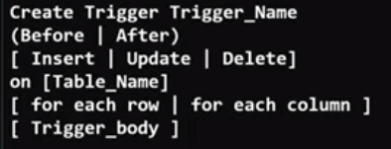

23.Create a trigger before/after update on the employee table for each row/statement.

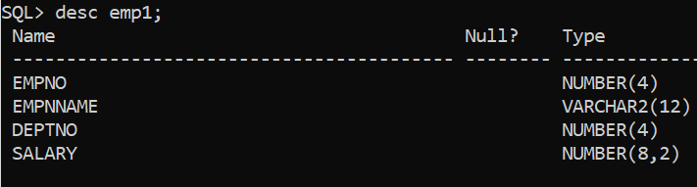

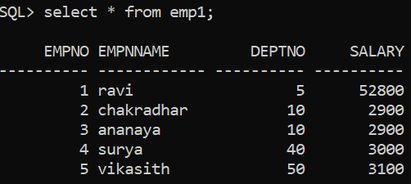

23)a)CREATE OR REPLACE TRIGGER T1

AFTER UPDATE ON EMP1

BEGIN

DBMS_OUTPUT.PUT_LINE('Row updated');

END;

/

Output:-

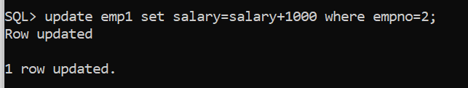

***************************************************************************

23)b)CREATE OR REPLACE TRIGGER T1

BEFORE UPDATE ON EMP1

BEGIN

DBMS_OUTPUT.PUT_LINE('Row updated');

END;

/

Output:-

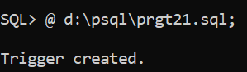

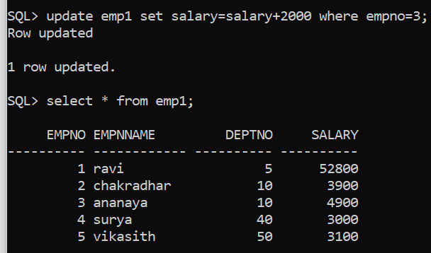

23)d)

CREATE OR REPLACE TRIGGER T6

BEFORE UPDATE OF SALARY ON EMP1

FOR EACH ROW

BEGIN

IF :NEW.salary< :OLD.salary THEN

RAISE_APPLICATION_ERROR(-20125, 'UPDATED SALARY CAN NOT BE LESSER THAN CURRENT SALARY');

END IF;

END;

/

Output:-

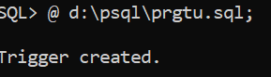

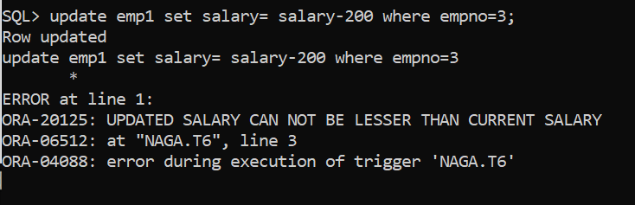

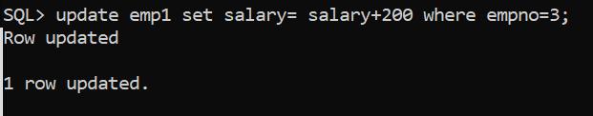

***************************************************************************

Week 14

24.Create a trigger before/after delete on the employee table for each row/statement.

25.Create a trigger before/after insert on the employee table for each row/statement.

24) Create a trigger before\after delete on the employee table for each row\statement.

CREATE OR REPLACE TRIGGER T6

BEFORE UPDATE OR DELETE OF SALARY ON EMP1

FOR EACH ROW

BEGIN

IF DELETING THEN

DBMS_OUTPUT.PUT_LINE('BEFORE DELETE TRIGGER FIRED');

END IF;

END;

/

Output:-

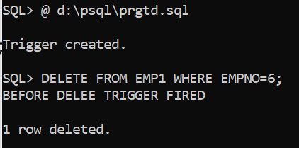

****************************************************************

25)Create a trigger before/after insert on the employee table for each row/statement.

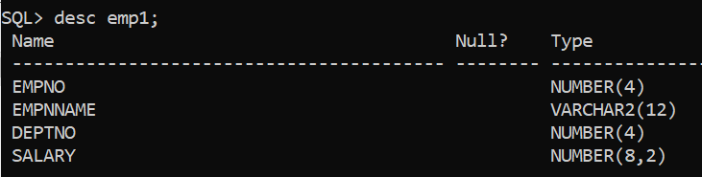

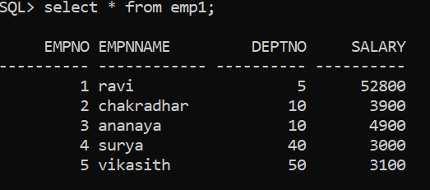

25.Create a trigger before/after insert on the employee table for each row/statement.

create or replace trigger t5

before insert on emp1

for each row

begin

dbms_output.put_line('row inserted');

end;

/

Output:-





